**Sample One-Page Abstract**

**for the TCCAT September Conference 2016**

Name in English (中文姓名一), Second Name (中文姓名二) Department of Cat, Schrödinger University, City, Country

[username@tac.cat.edu.tw](mailto:username@tac.cat.edu.tw)

This document is an example of one-page abstract for the TCCAT September conference. The goal of this abstracts is to provide information about the papers being presented. It also helps the conference committee to choose proper work to present if it is necessary. You can consider that this page is some sort of advertisement for your presentation, which will be used to decide if your presentation is worth listening to. Therefore, you can try to make it more attractive and informative. For this purpose, you can also include figures, such as Fig. 1, and a few optional references, such as [1] or [2].

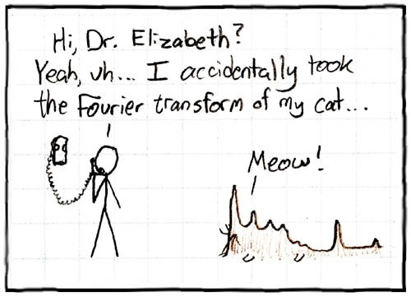

Figure 1: Picture took from [H T T P :/ / X K C D . C O M /2 6 /](http://XKCD.COM/26/)

The one-page abstract should be written in English and prepared as a one-page, A4, PDF file (size 210×297 mm) using the Times font, 16 pt for the title, 12 pt for the authors’ names and affiliations, and 11 pt for the text. The left and right margins should be 3.5 cm, the top margin 3 cm and the bottom margin 2 cm. We advise you to use the LATEX and MS Word templates provided on the conference website in order to ensure the correct formatting.

Please use the reference format of ACS for the references.

**References**

[1] Born, M.; Oppenheimer, R. *Annalen der Physik*, **1927**, *389*, 457–484.

[2] Lastname, Firstname; CollaboratorLastName, CollaboratorFirstName; BossLastName, BossFirstName, *Journal Name*, **201x**, *100*, 1234–5678.